Media Release
Yanara Partners with Local People’s Organization to Launch Forest Rehabilitation Program in Sual, Pangasinan
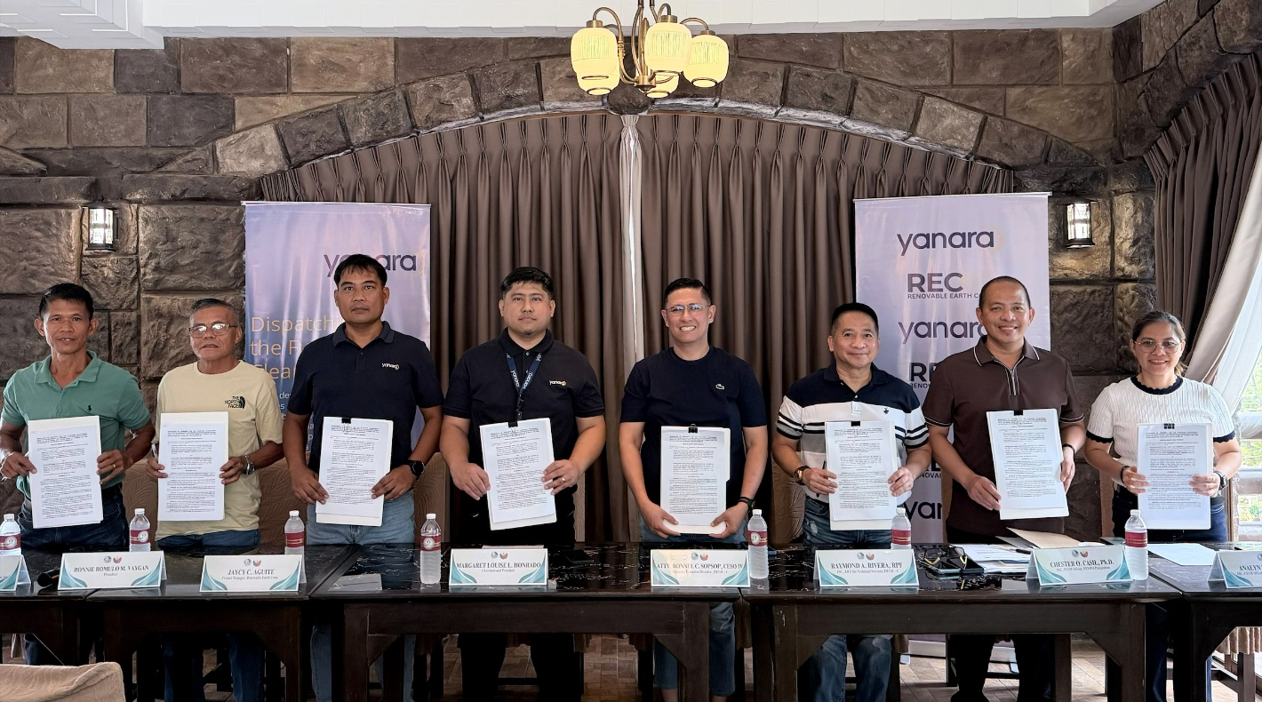
(L-R: SEFDAI Treasurer Albert Ramos, SEFDAI President Ronnie Romulo Vaygan, REC Project Manager Jaycy Aguite, Senior Projects Development Manager Freeman Manis, DENR R1 Regional Executive Director Atty. Ronnel Sopsop, Assistant Regional Director Raymond Rivera, OIC-PENRO Dr. Chester Casil, and OIC-CENRO Analyn Viray during the forest rehabilitation MOA signing in Barangay Macaycayawan, Sual, Pangasinan)
Sual, Pangasinan — August 4, 2026: Yanara, a pioneering renewable energy leader across the Asia-Pacific, has partnered with the Sioasio East Forest Developers Association, Inc. (SEFDAI), a local people's organization with experience in forest development and protection initiatives, to launch a large-scale plantation establishment and forest rehabilitation program in Sual, Pangasinan.
The partnership was formalized through a Memorandum of Agreement signed by Yanara’s subsidiary, Renovable Earth Corp. (REC), in the presence of key officials from the Department of Environment and Natural Resources (DENR) Ilocos Region, underscoring a shared commitment to environmental stewardship, biodiversity conservation, and sustainable community development.
Under the agreement, a total of 156,400 seedlings consisting of indigenous and fruit-bearing tree species will be planted and maintained across a 62.56-hectare plantation site located in Barangay Macaycayawan, Sual, neighboring Yanara’s 69 MWdc Sual Solar Power Plant. This solar plant is being constructed in partnership with ACEN, one of Philippines’ leading renewable energy companies, and falls under the Department of Energy’s Green Energy Auction Program 4 (GEA-4), a key national initiative to accelerate renewable energy deployment.
“As we advance the Philippines’ energy transition through the development of the Sual Solar Plant, our objective is to ensure the surrounding ecosystem thrives alongside our infrastructure. This partnership reflects Yanara's commitment to not only delivering reliable clean power to the national grid but also fostering long-term ecological balance and shared prosperity for the communities we serve,” said Margaret Honrado, Country Lead - Philippines, Yanara.
The plantation establishment project integrates a comprehensive five-year maintenance and protection program to ensure the long-term survival and growth of the planted seedling. SEFDAI will lead the implementation of plantation establishment and maintenance activities, spanning site preparation, plantation establishment, gap replanting, fire prevention measures, forest protection, and regular monitoring, with a targeted seedling survival rate of at least an 85 percent.
“We are pleased to be working with Yanara in this project that will help us, the environment, and our families,” said Ronnie Romulo M. Vaygan, President, SEFDAI. He also added that Yanara’s five-year commitment gives the members stable livelihood opportunities while allowing them to help restore their own backyards, ensuring the survival and growth of indigenous and fruit-bearing trees.
"This initiative brings together the scale and long-term commitment of renewable energy development with the deep, place-based knowledge of a local, people’s organizations. It reflects a more nuanced model of development, one that respects the land’s natural contours, strengthens community ownership, and ensures that environmental gains are both durable and inclusive. The DENR celebrates this collaboration and its promise to protect our region while putting the community at the heart of environmental conservation,” said Atty. Sopsop, Regional Executive Director, DENR Region 1.

ENDS

About Yanara
Yanara is a pioneering leader in advancing renewable energy across the Asia Pacific region, transforming availability into reliability through firm and dispatchable renewable power solutions. Our commitment is to meet the region's burgeoning electricity demand with innovative utility-scale hybrid multi-technology projects integrating solar, wind, and/or energy storage technologies. Yanara delivers safe, reliable, and cost-effective power solutions for utilities, industries, and digital infrastructure. With strong engineering and execution capabilities, we’re advancing the dual shift to cleaner power and deeper electrification—while creating lasting value for communities and customers alike. Operating in India, the Philippines, and Australia, Yanara is purpose-built for the next phase of the APAC energy transition. To learn more, visit: www.yanarapower.com
In the Philippines, Yanara has partnered with ACEN to develop, construct, and operate large-scale renewable power projects. It has secured a 20-year power purchase agreement with the Philippine government to supply clean electricity to the national grid from its 69 MWdc Sual Solar Plant, with delivery commitments scheduled between 2026 and 2029.
Press Contact
Anu Bararia
AVP & Head of Communications
anu.bararia@yanarapower.com

